FARIS ADEL EID ALAHMADI

[company name]

Report 1

Arabic Sentiment analysis

# Introduction

# Roadmap

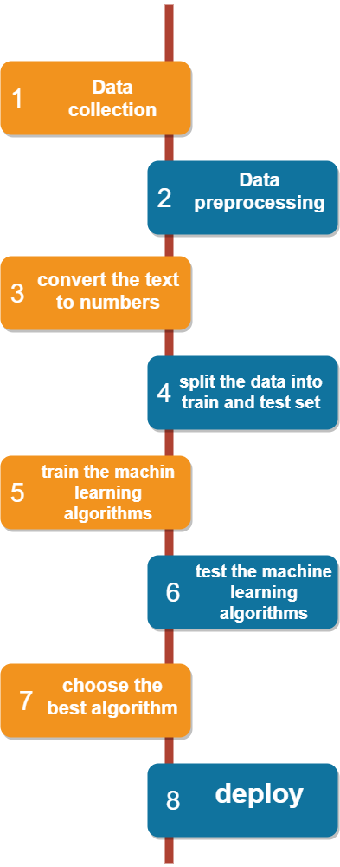As shown in the figure 1 the roadmap that we are going through is:

Figure

1. Data collection
2. Data preprocessing
3. Convert text to numbers
4. Split the data into train and test set
5. Train the machine learning algorithms
6. Test the machine learning algorithms
7. Choose the best algorithm
8. Deploy

The data collection step is explained in senior project 1, we describe the data and the source of each data set and the domine of the data. All the steps after step1 are in implementation phase.

# Data preprocessing

# Convert text to numbers

# Split the data into train and test sets

# Train the machine learning algorithms

# Test the machine learning algorithms

# Choose the best algorithm

# Deploy

# Conclusion